Task on Load Balancer
- Configure Classic Load balancer.

Objective:
To configure an AWS Classic Load Balancer (CLB) and distribute incoming HTTP traffic across multiple EC2 instances.

Prerequisites
Before starting, ensure you have:
- AWS account
- Two running EC2 instances
- Both EC2 instances in the same VPC
- HTTP web server installed on both instances
- Sample web page configured on both instances
- Security group allowing HTTP traffic on port 80

1. Create Classic Load Balancer

Step 1: Open Load Balancers
- Go to AWS Console → EC2.
- Select Load Balancers from the left navigation pane.
- Click Create Load Balancer.

Step 2: Select Load Balancer Type
You may see several types of load balancers.
Select: Classic Load Balancer

2. Configure Basic Load Balancer Settings
Enter:
Load Balancer name | My-Classic-LB
Scheme | Internet-facing
IP address type | IPv4

Listener Configuration
Configure:
Load Balancer Protocol | Load Balancer Port | Instance Protocol | Instance Port
HTTP | 80 | HTTP | 80
Click Next: Assign Security Groups.

3. Configure Security Group for CLB
Create a new security group.
Security group name: CLB-SG

Inbound Rule
Type | Protocol | Port | Source
HTTP | TCP | 80 | 0.0.0.0/0
Outbound: Leave the default All traffic → 0.0.0.0/0
Click Next: Configure Security Settings.

4. Configure Health Check
Configure the health check as:
Setting | Value
Ping Protocol | HTTP
Ping Port | 80
Ping Path | /
Response Timeout | 5 seconds
Interval | 30 seconds
Unhealthy Threshold | 2
Healthy Threshold | 2
The CLB will periodically access:
http://<EC2-private-IP>/
to determine whether the instance is healthy.
Click Next: Add EC2 Instances.

5. Add EC2 Instances
Select both EC2 instances:
EC2 Instance 1
EC2 Instance 2
Make sure both instances are selected.
Click Next: Add Tags.

6. Add Tags
Optional but recommended.
Key | Value
Name | My-Classic-Load-Balancer
Environment | Test
Click Review and Create.
Review the configuration.
Click Create

Configure Basic Load Balancer Settings
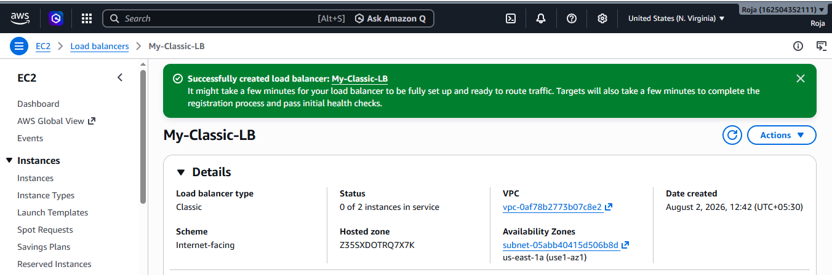

5. Verify Load Balancer
After creation:
- Go to EC2 → Load Balancers.
- Select My-Classic-LB.
- Check the Description tab.
- Copy the DNS name.
It will look similar to: My-Classic-LB-123456789.us-east-1.elb.amazonaws.com
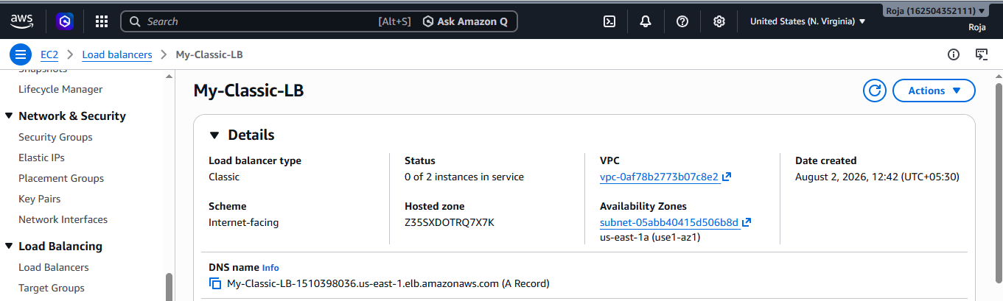

6. Test the Load Balancer
Open the CLB DNS name in your browser:
http://My-Classic-LB-123456789.us-east-1.elb.amazonaws.com
You should see the webpage served by one of the EC2 instances.
For example:
Hello from EC2 Instance 1
Refresh the page several times.
Because the CLB distributes requests between registered instances, you may see:
Hello from EC2 Instance 1
and:
Hello from EC2 Instance 2

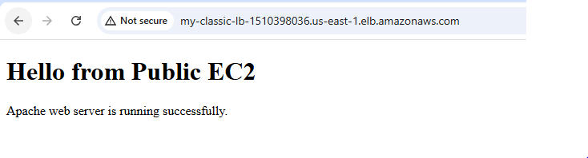
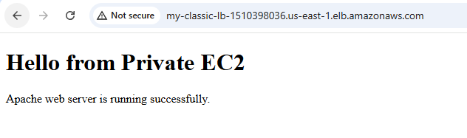

6. Verify Instance Health
EC2 → Load Balancers → My-Classic-LB
Open the Instances tab.
You should see:
Instance | Port | Status
CLB-Web-Server-1 | 80 | InService
CLB-Web-Server-2 | 80 | InService
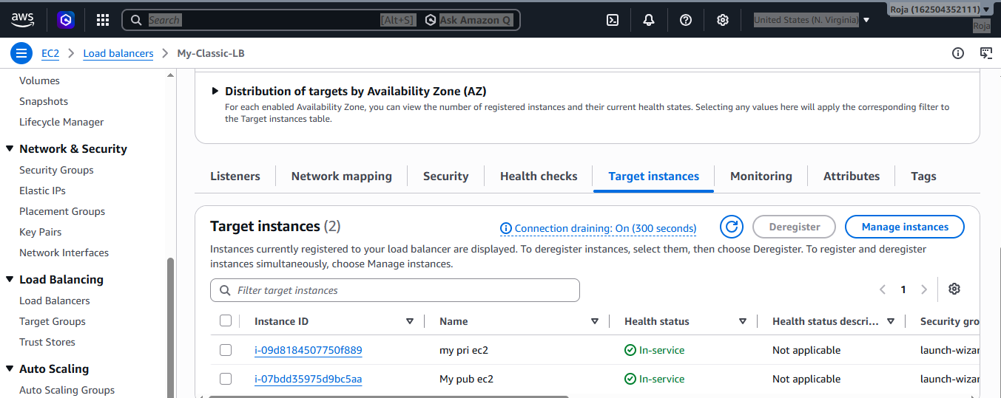
2. Configure Application Load balancer.

Objective
To create and configure an AWS Application Load Balancer (ALB) and distribute incoming HTTP traffic across two EC2 instances running Apache web servers.

Prerequisites
- AWS account
- One VPC
- At least two Availability Zones
- Two subnets in different Availability Zones
- Internet Gateway
- Two EC2 instances
- Apache installed on both instances
- Security groups
- Two EC2 instances running in the same VPC
1. Create Target Group
Now create the target group that will contain both EC2 instances.
Go to: EC2 → Target Groups → Create target group

Step 1: Choose Target Type
Select: Instances

Step 2: Basic Configuration
Setting | Value
Target group name | ALB-TG
Protocol | HTTP
Port | 80
VPC | ALB-VPC
IP address type | IPv4
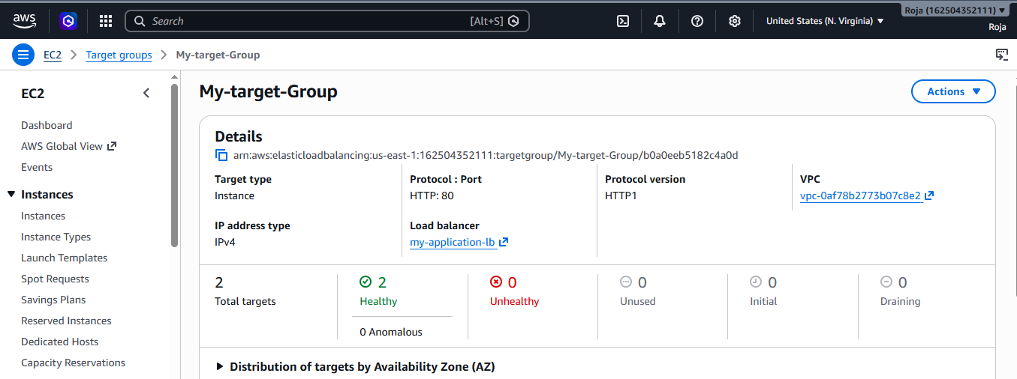
2. Configure Health Check
Under Health checks, configure:
Setting | Value
Health check protocol | HTTP
Health check path | /
Port | Traffic port
Healthy threshold | 2
Unhealthy threshold | 2
Timeout | 5 seconds
Interval | 30 seconds
Success codes | 200
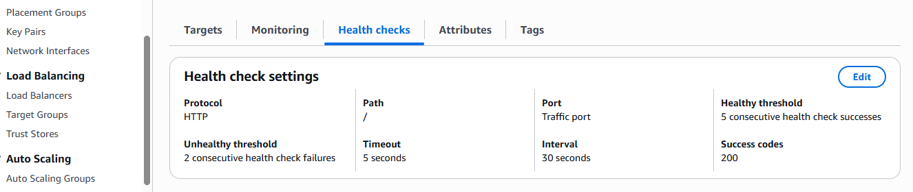
3. Register EC2 Instances
AWS Console → EC2 → Target Groups → Create target group
After completing the basic target group settings, you will reach:
Register targets
You should see your EC2 instances.
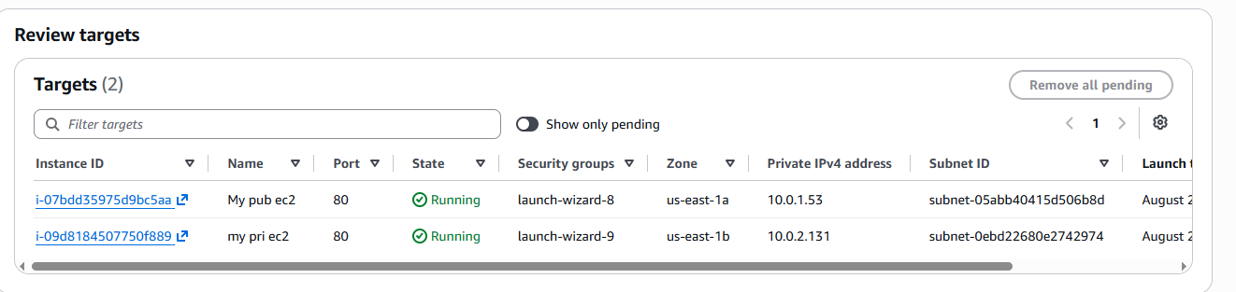

4. Create Application Load Balancer
EC2 → Load Balancers
Click: Create Load Balancer
Select: Application Load Balancer
Click Create.
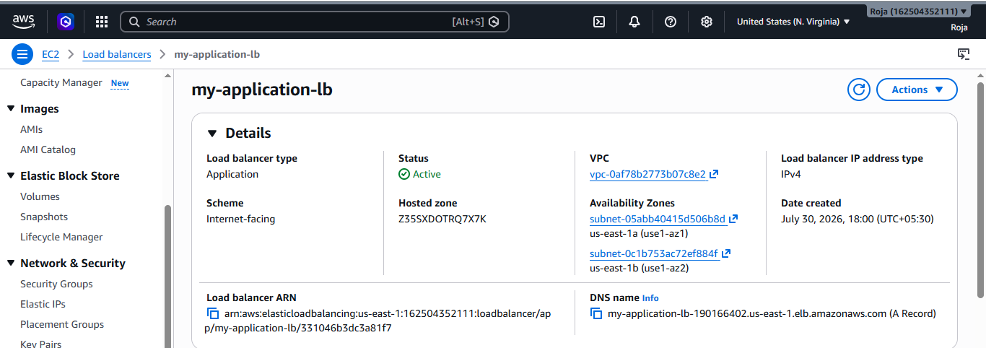
5. Verify Target Health
EC2 → Target Groups → My-target-Group → Targets
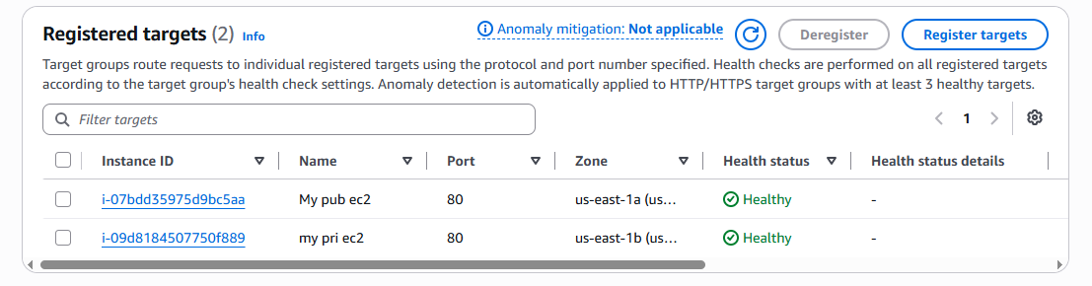

6. Test the Application Load Balancer
EC2 → Load Balancers → my-application-lb
Copy the DNS name.
It will look similar to: my-application-lb-xxxxxxxx.us-east-1.elb.amazonaws.com
Open: http://my-application-lb-xxxxxxxx.us-east-1.elb.amazonaws.com
You should see your Apache webpage.
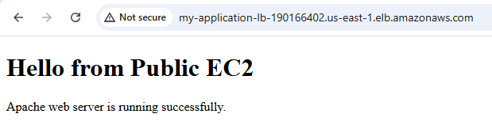

3. Configure Network Load balancer.

Objective
To configure an AWS Network Load Balancer (NLB) and distribute TCP traffic across two EC2 instances.

Prerequisites
- AWS account
- One VPC
- Two subnets in different Availability Zones
- Two EC2 instances
- Apache installed and running on both EC2 instances
- Port 80 available on both EC2 instances
1. Create Target Group
EC2 → Load Balancing → Target Groups
Click: Create target group
Select : Target type: Instances
Enter: Target group name: NLB-Target-Group
Protocol: TCP
Port: 80
IP address type: IPv4
VPC: Select your VPC
Under Health checks, configure:
Health check protocol: TCP
Health check port: Traffic port

2. Register EC2 Instances
Select 2 instances
Port: 80
Click: Include as pending below
You should see:
Pub instance-1 TCP 80
Pri instance-2 TCP 80
Click: Create target group

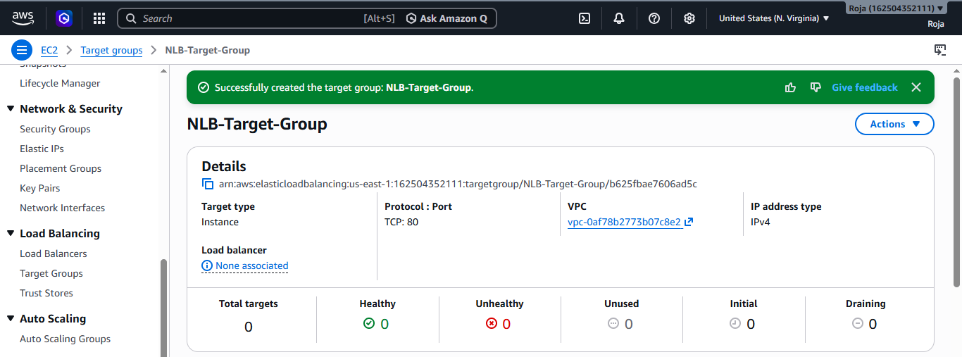

3. Verify Target Health
EC2 → Target Groups → NLB-Target-Group → Targets
Initially, the targets may show: Initial
Wait for the health checks to complete.
The expected result is:
Pub instance-1 Healthy
Pri instance-2 Healthy
You should have:
Total targets: 2
Healthy: 2
Unhealthy: 0
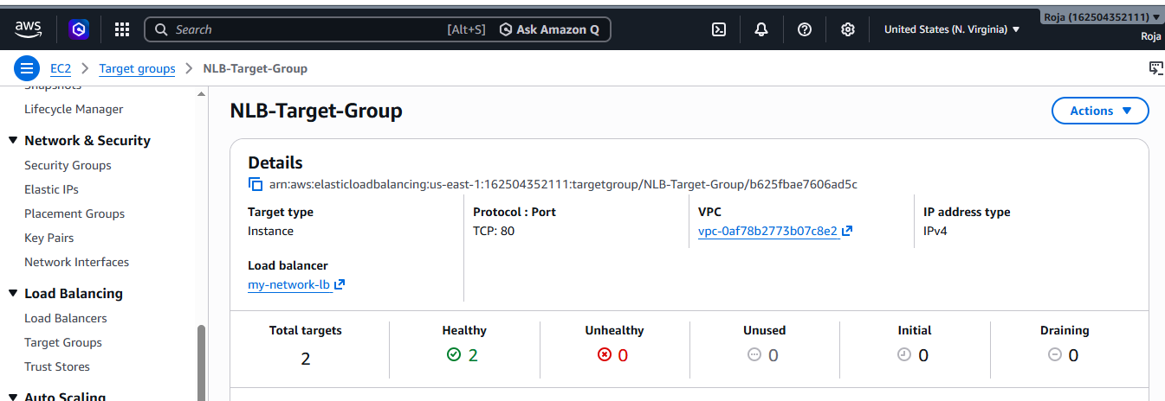

3. Create Network Load Balancer
EC2 → Load Balancers
Click: Create Load Balancer
Select: Network Load Balancer
Click: Create
Enter: Load balancer name: my-network-lb
Scheme: Internet-facing
IP address type: IPv4
Scheme
Select: Internet-facing
This allows clients from the internet to access the NLB.

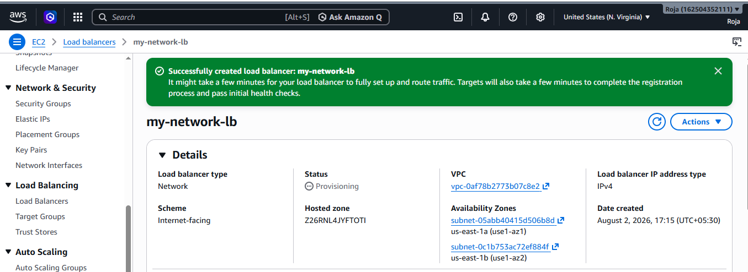

4. Test the Network Load Balancer
EC2 → Load Balancers → my-network-lb
Copy the DNS name.
It will look similar to: my-network-lb-xxxxxxxx.elb.amazonaws.com
Open the following in your browser: http://YOUR-NLB-DNS-NAME
You should see your Apache webpage.
You can also test using: curl http://YOUR-NLB-DNS-NAME
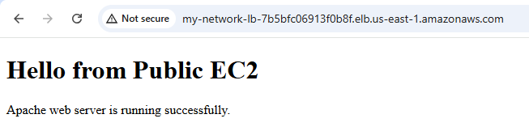
4. Attach SSL for application load balancer.

Objective
To configure SSL/TLS HTTPS on an Application Load Balancer (ALB) using an SSL certificate from AWS Certificate Manager (ACM).

Prerequisites
- An Application Load Balancer
- A target group
- EC2 instances registered in the target group
- Targets showing Healthy
- A domain name, such as: example.com
- Access to the domain's DNS settings

1. Request an SSL Certificate
- AWS Console → Certificate Manager (ACM)
- Make sure you select the same AWS Region as your Application Load Balancer.
- For example, if your ALB is in:
- US East (N. Virginia) – us-east-1
- ACM must also be in:
- US East (N. Virginia) – us-east-1

Step 1: Open Certificate Manager
- AWS Console → Certificate Manager → List certificates
- Click: Request

Step 2: Choose certificate type
- Select: Request a public certificate
- Click:Next

Step 3: Enter domain name
- Enter your domain.
- Click: Request
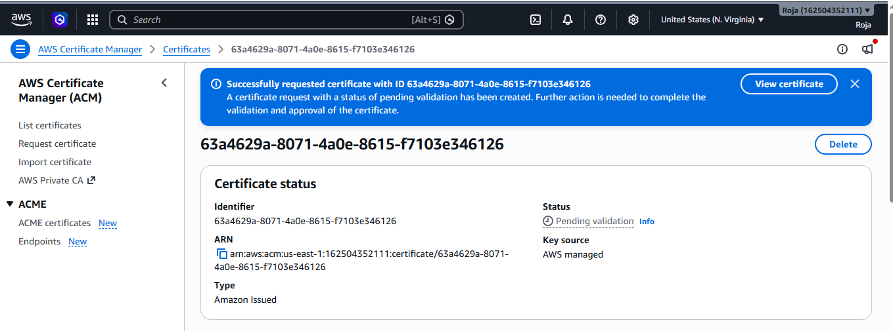
2. Validate the Certificate

- After requesting the certificate, its status will initially be: Pending validation
- Open the certificate.
- Under Domains, choose:
- Create records in Route 53
- If your domain's DNS is hosted in Route 53.
- Then click: Create records
- AWS will create the required DNS validation records.
- Wait until the certificate status changes from:
- Pending validation to: Issued
- If your DNS is NOT hosted in Route 53
- ACM will provide a CNAME record.
- Add that CNAME record at your domain provider.
- Then wait for ACM validation.
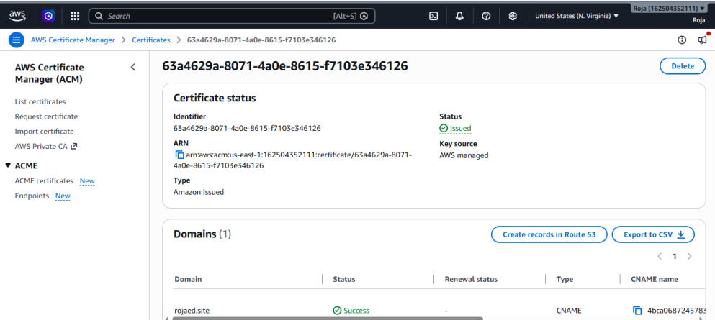

3. Add HTTPS Listener to the ALB
- Once the certificate shows:
- Status: Issued
- go to: EC2 → Load Balancers
- Select your Application Load Balancer.
- Go to: Listeners and rules
- Click: Add listener

Protocol : HTTPS

Port: 443

Default action
Select:
Forward to
Then choose your existing target group.
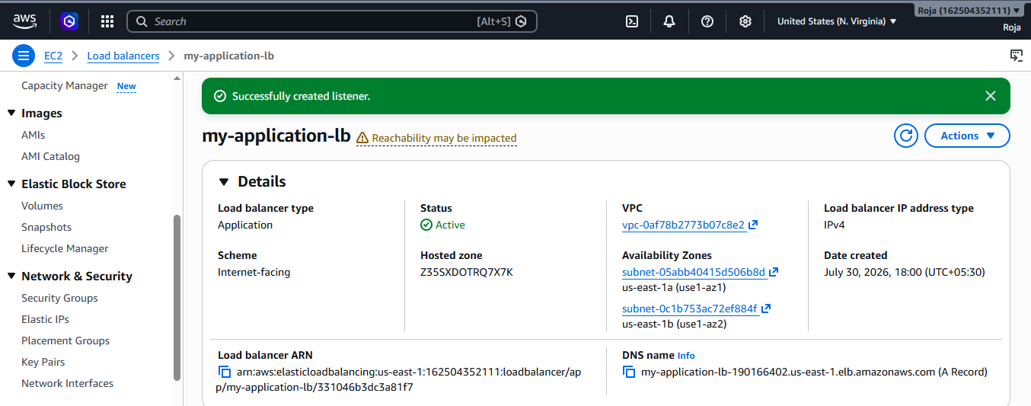
4. Configure ALB Security Group
Type | Protocol | Port | Source
HTTPS | TCP | 443 | 0.0.0.0/0
HTTP | TCP | 80 | 0.0.0.0/0
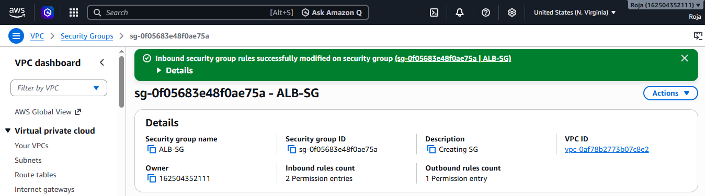
5. Test HTTPS
Copy your domain name and open:
https://example.com
You should see your application.
You can also test the ALB DNS name:
https://your-alb-name.us-east-1.elb.amazonaws.com

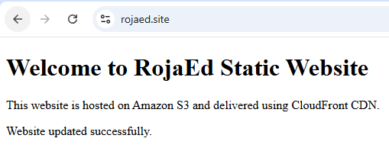

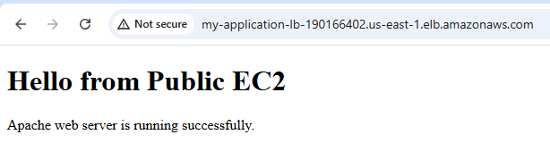
5. Map Application load balancer to R53.

Objective
To create a Route 53 DNS record that maps a custom domain name to an Application Load Balancer (ALB).
After configuration, users can access the application using:
https://rojaed.site
instead of the ALB's long DNS name.

Prerequisites
- An Application Load Balancer is already created.
- The ALB is Active.
- The ALB has a listener configured.
- The target group contains your EC2 instances.
- Target instances are Healthy.
- You own/control the domain rojaed.site.
- The domain is hosted in Route 53, or you can update its nameservers at your domain registrar.
- If using HTTPS, an ACM certificate for rojaed.site is Issued and attached to the ALB's HTTPS listener.

Step 1: Check the ALB
AWS Console → EC2 → Load Balancers
Select your Application Load Balancer.
Check:
State: Active
Scheme: Internet-facing
Copy the DNS name if needed.
It will look similar to:
my-application-lb-123456789.us-east-1.elb.amazonaws.com
Do not create an A record pointing directly to this DNS name. For an ALB, Route 53 should use an Alias record.
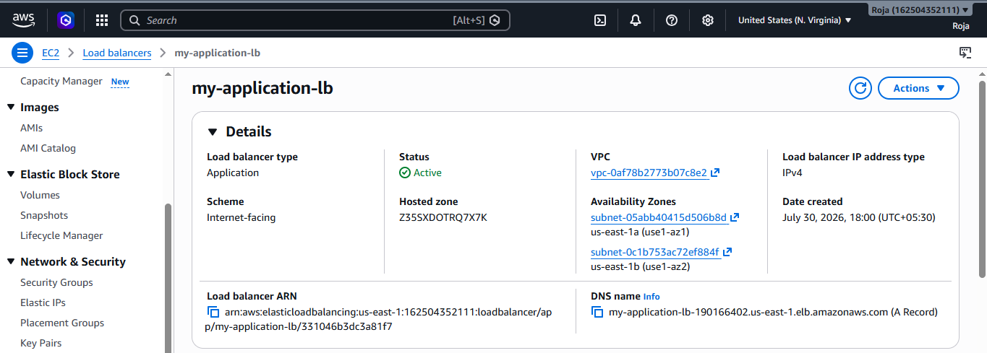

Step 2: Open Route 53
AWS Console → Route 53
Select: Hosted zones
You should see: rojaed.site
Click: rojaed.site

Step 3: Create an A Record
Click: Create record
Configure it as follows: Record name
For the root domain: Leave this field blank
This creates: rojaed.site

Record name : [blank]
Record type : A
Alias : Yes
Route traffic to: Application Load Balancer
Region : us-east-1
Load Balancer : my-application-lb
Create records
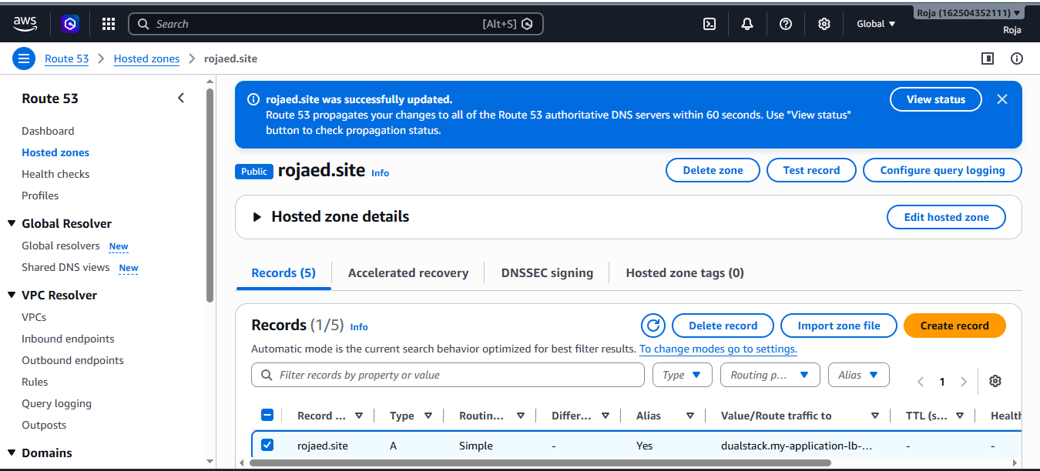
Step 4: Create www Record
If you also want: www.rojaed.site create another record.
Click: Create record
Use:
Record name: www
Record type: A
Alias: Yes
Route traffic to: Application Load Balancer
Region: us-east-1
Load Balancer: my-application-lb
Step 5: Verify the Records
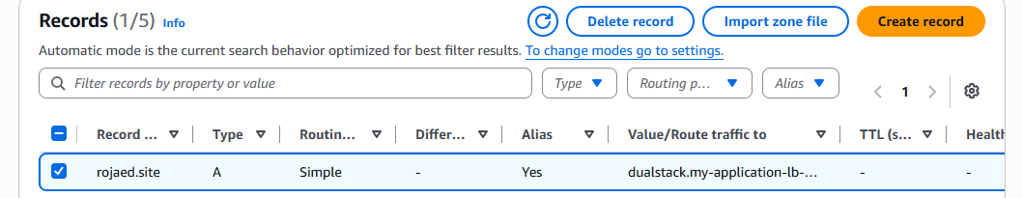

Step 6: Check Domain Nameservers
This step is very important if your domain was purchased somewhere other than Route 53.
In Route 53: Hosted zones → rojaed.site → Hosted zone details
Copy the 4 Route 53 nameservers.
They will look similar to:
ns-123.awsdns-xx.com
ns-456.awsdns-xx.net
ns-789.awsdns-xx.org
ns-012.awsdns-xx.co.uk
Go to your domain registrar where rojaed.site was purchased.
Find:
Nameservers / DNS / Custom Nameservers
Replace the existing nameservers with the Route 53 nameservers.
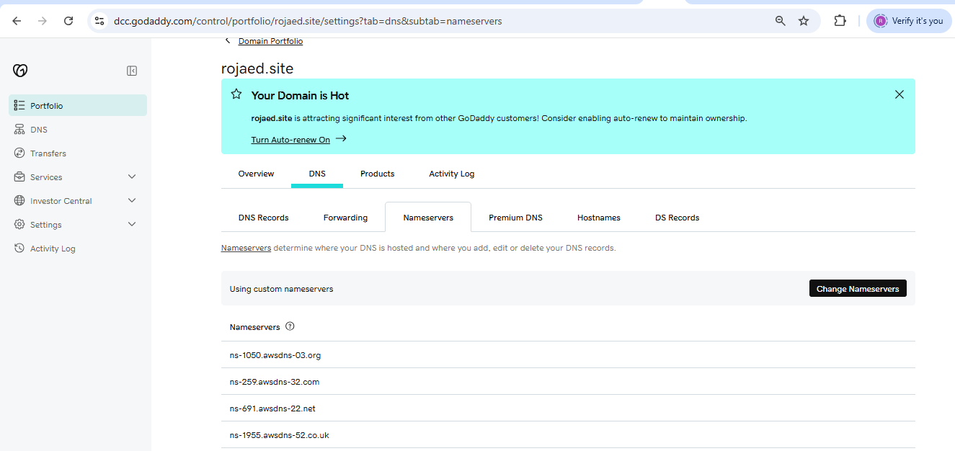
Step 7: Verify DNS Resolution
Wait for DNS propagation.
Then open Terminal and run:
nslookup rojaed.site

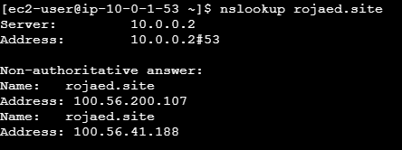

Step 8: Test the Website
If your ALB has an HTTP : 80 listener, test:
http://rojaed.site
If you configured the HTTPS : 443 listener with your ACM certificate, test:
https://rojaed.site
You should see your application/web page.
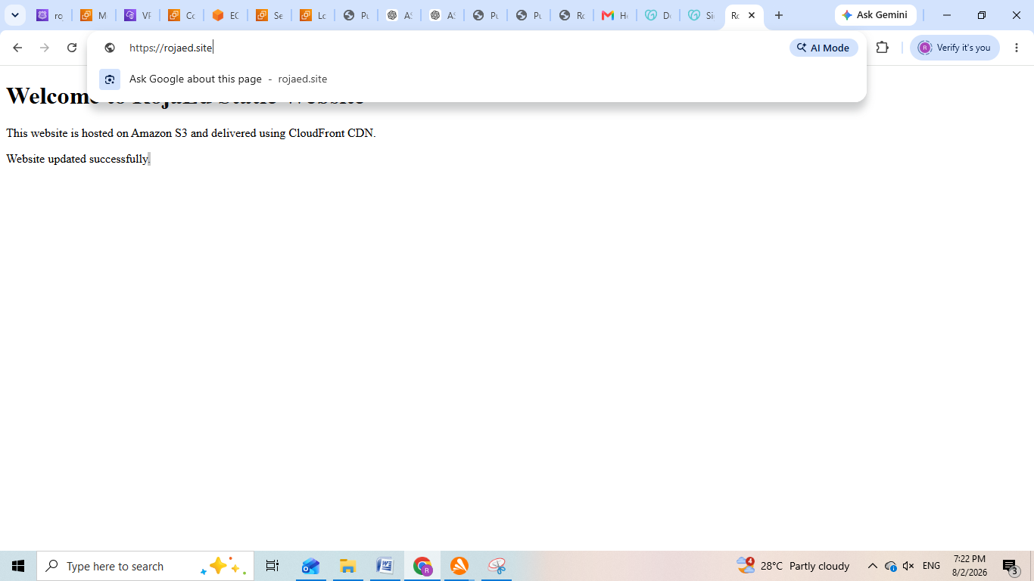
6. Push the application load balancer logs to S3.

Objective
To enable access logs for an Application Load Balancer (ALB) and store the logs in an Amazon S3 bucket for monitoring, troubleshooting, and auditing.

Prerequisites
- An Application Load Balancer already created.
- An S3 bucket.
- Permission to modify the ALB and S3 bucket.
- ALB and S3 bucket in the appropriate AWS Region.

1. Create an S3 Bucket
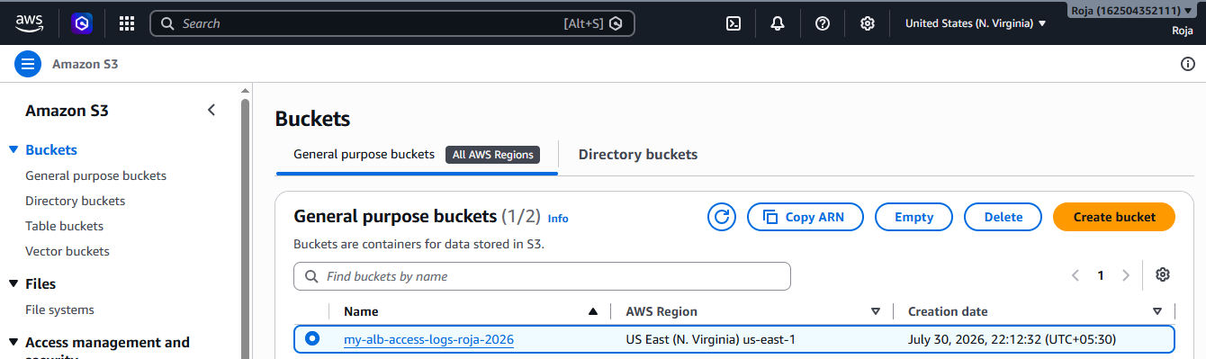

2. Configure S3 Bucket Policy
Now open:
S3 → Your bucket → Permissions → Bucket policy
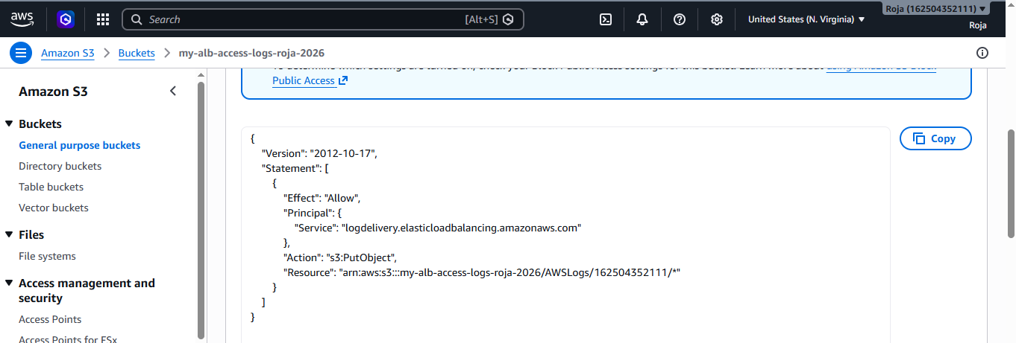

3. Enable ALB Access Logs
AWS Console → EC2 → Load Balancers
Select your Application Load Balancer.
Then select: Attributes
Find: Monitoring
Look for: Access logs
Click: Edit
Enable: Access logs: On
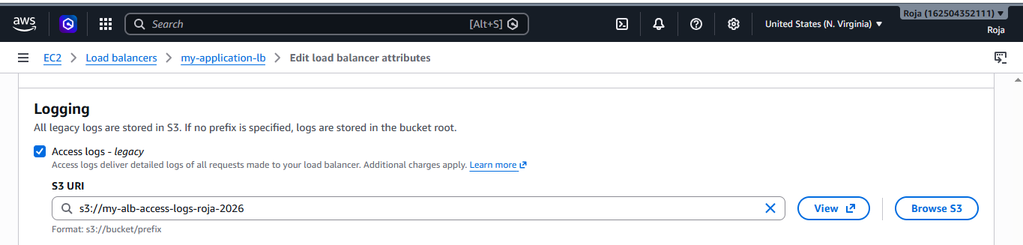

4. Generate Traffic Through the ALB
Access your ALB several times.
Copy your ALB DNS name from:
EC2 → Load Balancers → Your ALB → DNS name
Open it in your browser: http://YOUR-ALB-DNS-NAME
You can also run: curl http://YOUR-ALB-DNS-NAME
Run the request several times:
for i in {1..10}; do curl -s http://YOUR-ALB-DNS-NAME > /dev/null; done

5. Verify logs:
Wait a few minutes and then go to:
S3 → Your bucket S3 Bucket │
└── AWSLogs │
└── 123456789012 │
└── elasticloadbalancing │
└── us-east-1 │
└── 2026 │
└── 08 │
└── 02 │
└── *.log.gz

Below is the log file from Notepad:

http 2026-08-01T23:59:57.453959Z app/my-application-lb/331046b3dc3a81f7 146.190.169.94:24068 - -1 -1 -1 503 - 327 734 "GET http://100.56.41.188:80/ HTTP/1.1" "Mozilla/5.0 (Macintosh; Intel Mac OS X 10_15_7) AppleWebKit/537.36 (KHTML, like Gecko) Chrome/120.0.0.0 Safari/537.36" - - arn:aws:elasticloadbalancing:us-east-1:162504352111:targetgroup/My-target-Group/b0a0eeb5182c4a0d "Root=1-6a6e887d-336a69a23f64666a7aa78670" "-" "-" 0 2026-08-01T23:59:57.453000Z "forward" "-" "-" "-" "-" "-" "-" TID_83453418bb574a43bb6658a622545054 "-" "-" "-" 100.56.41.188

